 CHEMICAL ENGINEERING TRANSACTIONS  VOL. xxx, 2026 | A publication of  
The Italian Association
of Chemical Engineering
Online at www.cetjournal.it

Guest Editors: Laura Capelli, Marzio Invernizzi, Selena Sironi
Copyright © 2026, AIDIC Servizi S.r.l.
ISBN 979-12-81206-xx-x; ISSN 2283-9216

Deep Learning and AI-based processing of Fuzzy eNose data
Simon Bootsma^{b}, Hugo Speeª
ªCarapax IT, Stationsplein 9, Gouda, The Netherlands
^{b}Comon Invent, Burgemeestersrand 198, The Netherlands
bootsma@comon-invent.com
  - Introduction

Instruments capable of detecting changes in atmospheric composition are commonly referred to as electronic noses (eNoses), a term inspired by the biological sense of smell. The human nose forms part of the olfactory system, in which receptors are continuously exposed to ambient air. Signals generated by these receptors are transmitted to the brain, where they are interpreted as odor-related information.
Certain odors are perceived as pleasant, whereas others evoke aversion. This reflects the primary biological function of olfaction: responding to airborne substances relevant to the survival of the species. Pleasant odors may indicate suitable food sources or safe environments, while unpleasant odors can signal spoiled food or other hazards. Olfaction may therefore trigger instinctive fight-or-flight responses.
In 1998, we initiated the development of an electronic instrument capable of detecting changes in the chemical composition of ambient air. The project began with a market exploration of suitable gas sensor technologies. All available sensor types were evaluated under both laboratory and real-world field conditions. This development ultimately resulted in an instrument based on an array of four semiconductor gas sensors combined with a sensor measuring relative humidity and temperature in the vicinity of the sensor array.

During the past 25 years, a substantial number of case studies has been conducted concerning the emergence and dispersion of emissions associated with odor nuisance and hazardous incidents. The rapid development of artificial intelligence techniques is now being applied to improve the detection and interpretation of unusual situations using eNose networks
  - Methods
The raw sensor data of the eNose are transmitted wirelessly at one-minute intervals to a cloud-based data lakehouse environment. A data lakehouse is a modern data architecture in which structured and unstructured information from multiple sources is integrated. In addition to eNose measurements, the platform stores meteorological data, citizen odor complaints, and quantitative parameters obtained from analytical instruments at air quality monitoring stations.
Over the past decades, extensive in-house research has been conducted using this data lakehouse infrastructure, leading to applications ranging from online odor nuisance monitoring and odor mapping to systems supporting industrial and environmental safety.
Although we possess extensive experience in developing such applications independently, collaboration with academic institutions and specialized companies has become increasingly important. A recent case study formed the basis of a collaborative research project with the Department of Chemometrics at Radboud University. Since 2022, intensive collaboration has also taken place with Carapax IT, a company specializing in advanced data science and software engineering.

Our eNose consists of an array of semiconductor sensors. The operating principle of a semiconductor gas sensor is based on a measurable change in electrical conductivity when the concentration of reactive molecules in the vicinity of the sensor changes. The active layers of the semiconductor sensors are composed of metal oxides containing slightly different dopants. As a result, each sensor responds differently to specific molecules present in a gas mixture. The combined response pattern of all sensors in the array is referred to as the fingerprint of the eNose for that gas mixture.
Because all odours consist of reactive molecular mixtures, the eNose is inherently capable of detecting odours. However, although every odor contains reactive molecules, not every reactive molecule is odorous to humans. In fact, many reactive compounds are completely odourless to the human olfactory system. For this reason, we consider it inappropriate to characterize our eNose technology merely as an odor sensor or as an Instrumental Odor Monitoring System (IOMS).
The eNose detects trace concentrations of arbitrary gas mixtures that may have entered the atmosphere incidentally. Consequently, extraction of meaningful fingerprints from noisy sensor data is essential.
A study conducted by the Department of Chemometrics at Radboud University focused on an incident in which several eNoses detected the dispersion of a hydrogen plume originating from a source located more than 90 km away. The results demonstrated that, in addition to the hydrogen plume under investigation, the eNose network was simultaneously able to distinguish traffic-related emissions and a third unidentified plume originating from a nearby source.

One of the primary research questions at the start of our collaboration with Carapax IT concerned the development of sufficiently robust processing methods for eNose and contextual data to enable reliable automated analysis. Various data analysis techniques were applied, including anomaly scoring based on the Isolation Forest algorithm. In addition, a weather scoring methodology was developed.
During rainfall events, rapid increases in atmospheric humidity and decreases in temperature occur. Semiconductor sensors are sensitive to such changes, potentially resulting in false-positive detections. The weather scoring methodology enables the anomaly detection system to distinguish between signal changes caused by alterations in atmospheric chemical composition and those resulting from meteorological variability.
In the initial phase of the project, substantial efforts were devoted to SHAP and ROC explainability analyses, as well as to the development of tooling for automated source detection.

An example is shown below. The right y-axis presents the results of the anomaly detector applied to an eNose network surrounding an industrial site containing an anaerobic digester, a biogas storage tank, and a composting facility. The left y-axis indicates the timing of odor nuisance complaints submitted by residents to the environmental authority. The graph covers 24 and 25 December 2012.

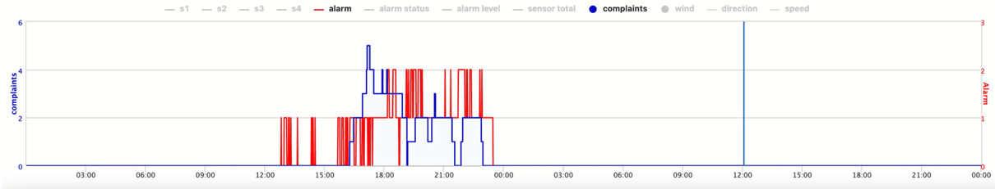
Figure 1. Anomalies detected by the eNose network (red) and complaints (blue)

On 24 December, the anomaly detector indicated between 12:45 and 23:30 that initially one eNose, and from 18:00 onward two eNoses, detected an outbreak of unusual emissions. Between 16:00 and 23:00, several odor complaints were also received from nearby residents. The time window during which complaints were submitted coincided with the period in which the anomaly detector identified abnormal emissions along the perimeter of the industrial site.
These results demonstrate a clear temporal and spatial relationship between perceived odor nuisance and eNose observations. The eNose registered the anomaly at approximately 16:00, whereas the corresponding complaint was submitted nearly one hour later.
The Royal Netherlands Meteorological Institute (KNMI) operates its own meteorological forecasting model known as HARMONIE (HIRLAM ALADIN Research on Mesoscale Operational NWP in Euromed). In a subsequent research phase, this model was integrated into the data lakehouse infrastructure.
Using this integration, the propagation of eNose signals can be modelled spatially and temporally. Within a network of eight eNoses, two sensors detecting an anomaly are sufficient for the model to calculate, every ten seconds, how the corresponding eNose observation propagates through space under prevailing wind conditions. This approach is based on the principles of a Lagrangian Particle Model.
Dispersion modeling enables not only tracking of “eNose plumes” and analysis of their relationship with odor complaints, but also source tracing.
Once the source has been identified, a forward dispersion model can be configured for that source. This forward model can subsequently be continuously validated using observations from the eNose network. An increase in source strength results in stronger signals at downwind eNoses, and vice versa. Consequently, dispersion models traditionally driven by static emission parameters can evolve into dynamic models incorporating fluctuating emission rates derived and real-time validated by sensor observations and sensory reports.

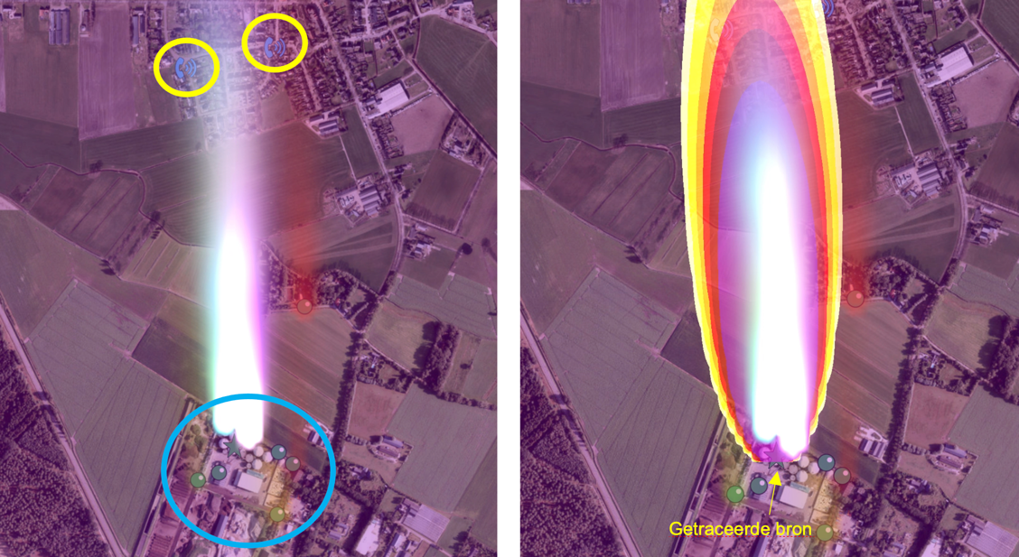
Figure 2 left eNose 'plumes' - right plume modelled from identified source

The same methodology was applied in the example below. On nuisance episode caused by a vessel that was degassing its tanks while sailing. On October 1, 2023, about 30 complaints were recorded in a timeframe of less than 15 minutes. An algorithm called the Degassing Vessel Detective identified the ship that was emitting product vapours from its tanks. It was a mercaptan rich crude oil vapour, called CPC blend. The eNose recordings and the complaints were used to model and validate the plume on-the-flight.

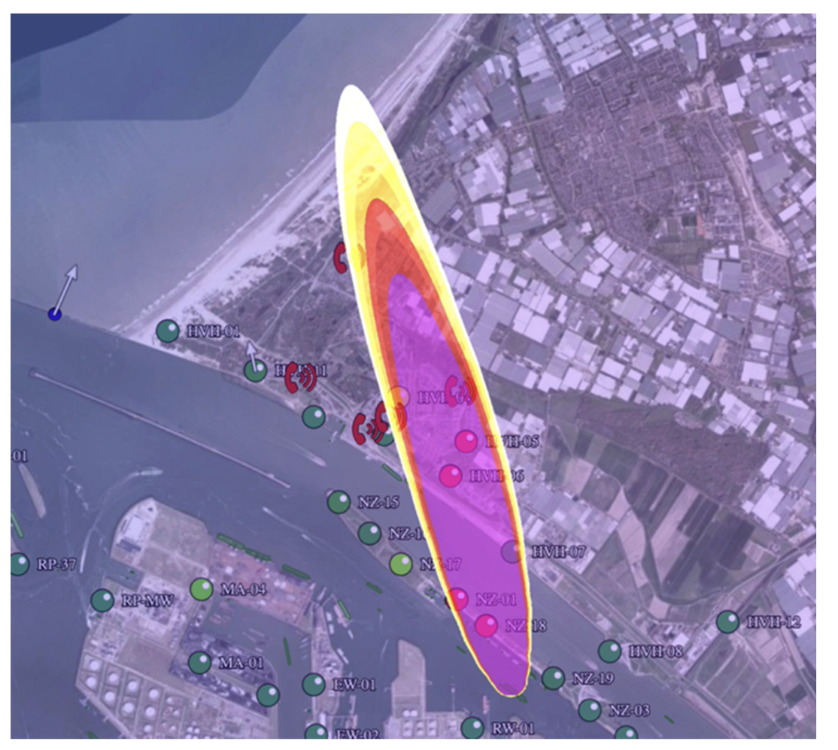
Figure 3 Plume from moving source caused anomalies on the eNoses as well 30 complaints

Because the product vapour that was emitted was known we could assess the peak concentrations that were recorded from the various eNoses in the area that were affected by the passing plume. We could do this, because we have trained the eNose for this product vapour. By translating the raw data of all affected eNoses with this curve we could record the peak recordings of the eNoses as a function of the location of the (moving) emission source, we could define the dilution profile that was recorded by the eNoses.

It was found that eNoses closest to the source have recorded a small, but intense peak up to 1,000 OU_{E}.m⁻³, The concentration of the eNoses in the town where the emission generated the nuisance eNoses recorded op to 50 OU_{E}.m⁻³.
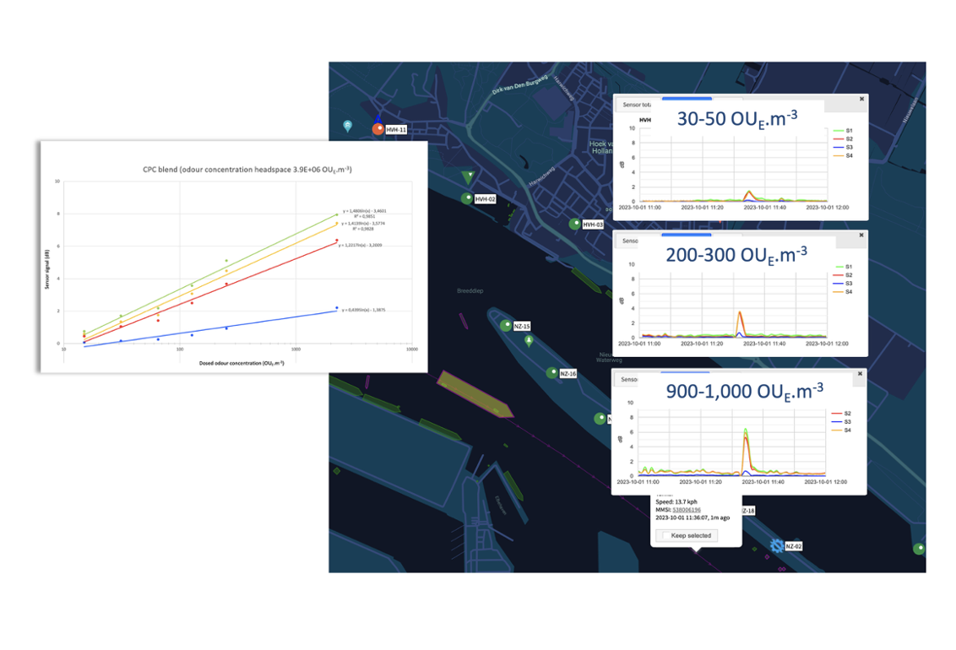
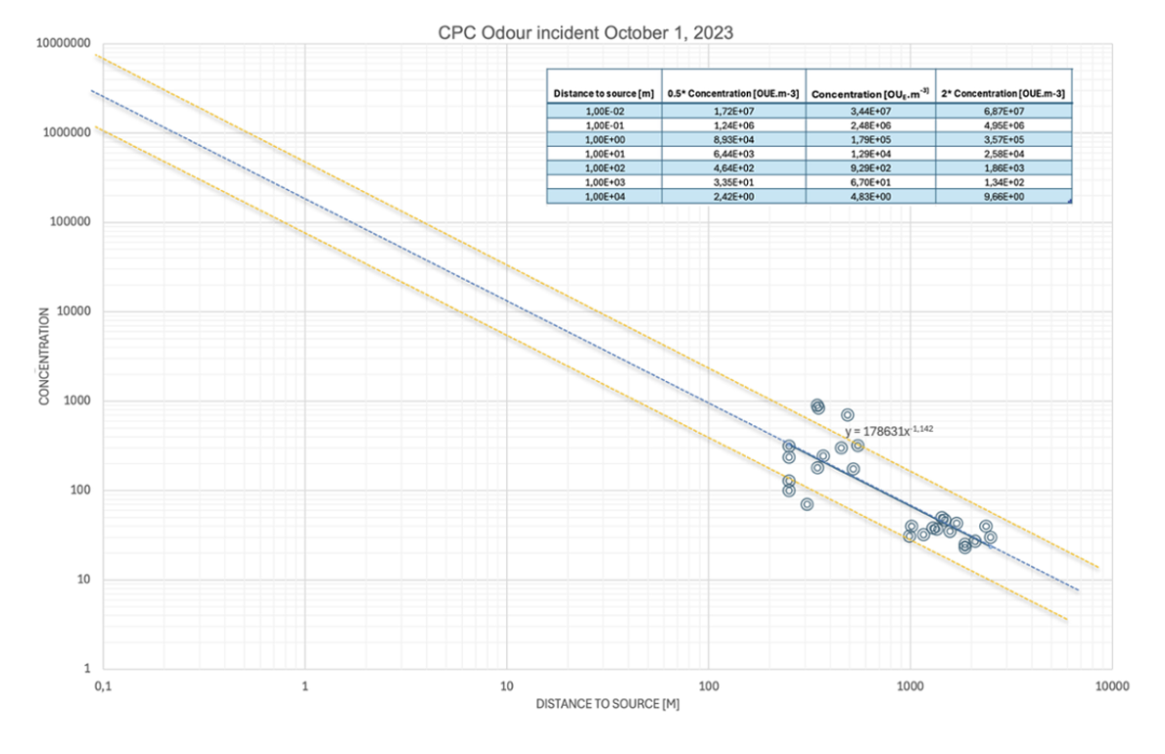

Figure 4 Odour assessment of peak recordings translated with sensitivity curve of the trained product vapour

Odour nuisance caused by tankers venting their tanks is a recurring issue in many seaports because the high mercaptan crude oils are stored in many oil terminals in the large seaports and used as feed stock of refineries.

After unloading its cargo, the vessels are venting their tanks with an inert gas as a safety measure. At sea this can be done by blowing their exhaust fumes through the tank. This causes an emission of the product vapours to the atmosphere. On December 12, 2025, the plume spread of such an inerting activity at sea was recorded by several eNose networks in a range up to 110 km

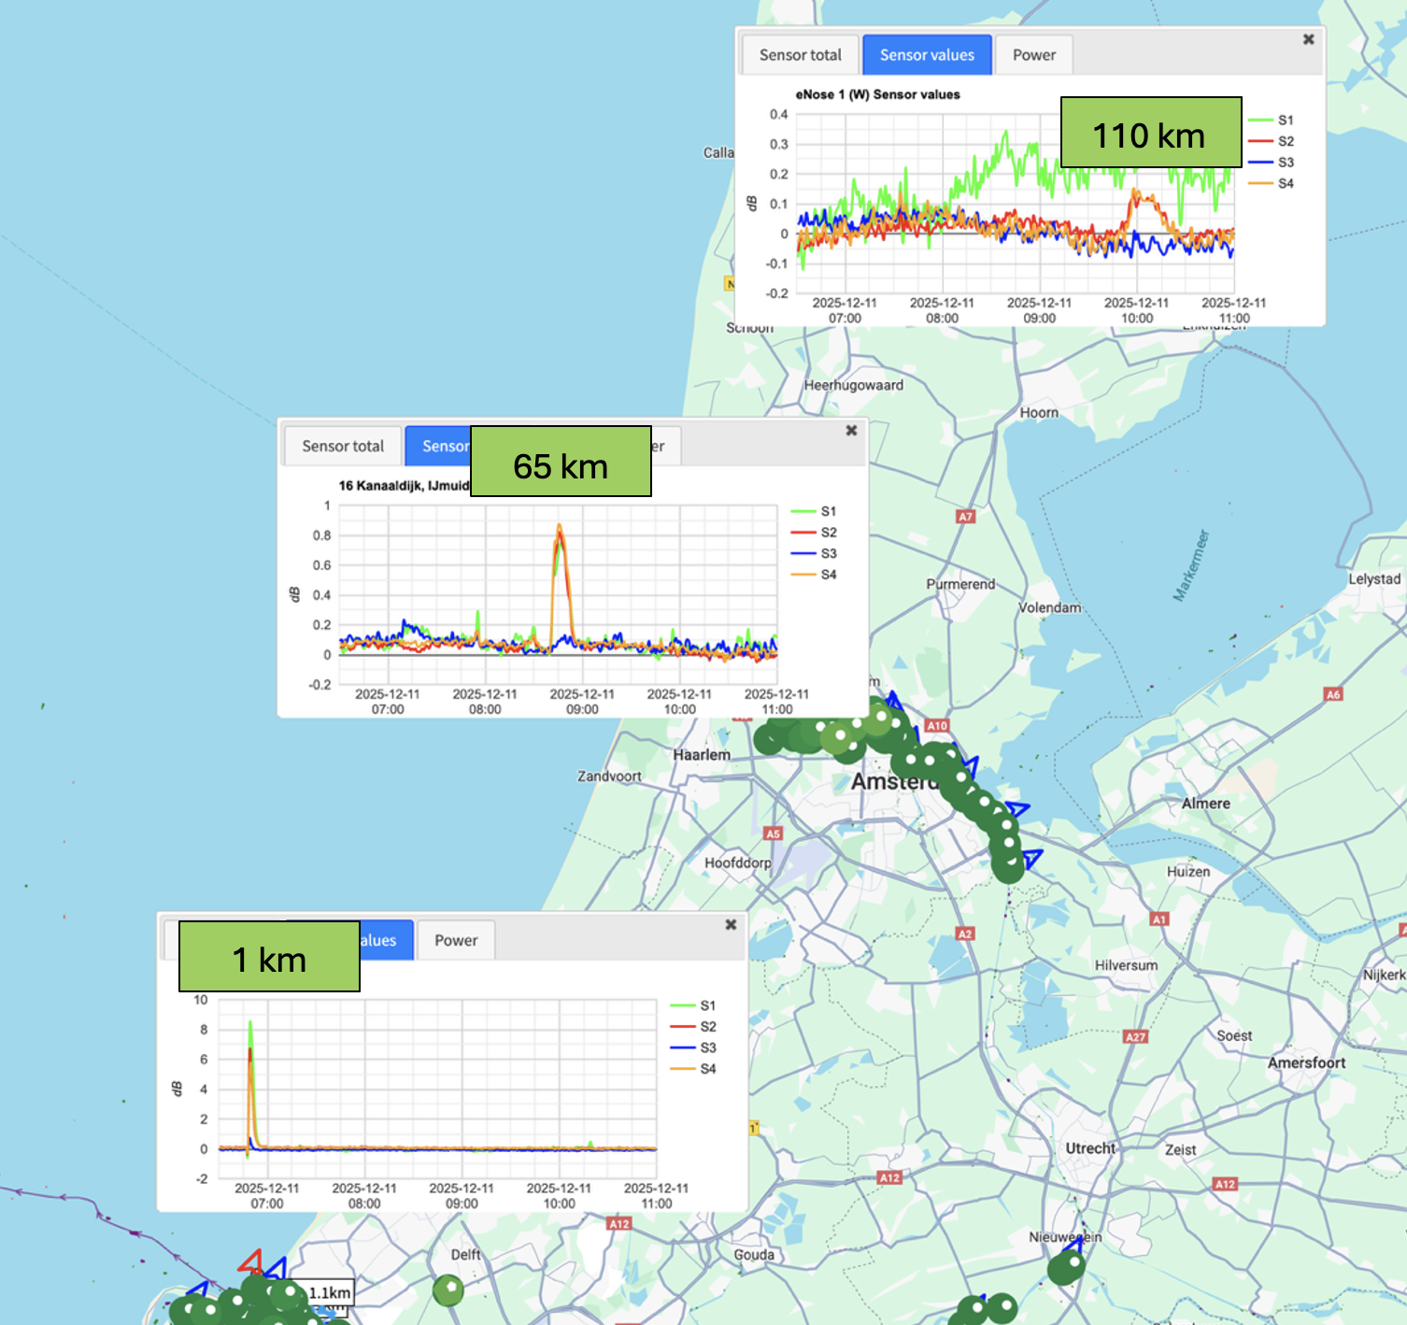
Figure 5 eNoses recorded anomalies up to 100 km downwind from the source

The eNose at 65 km downwind showed a time and place relation between the complaint and eNose recording

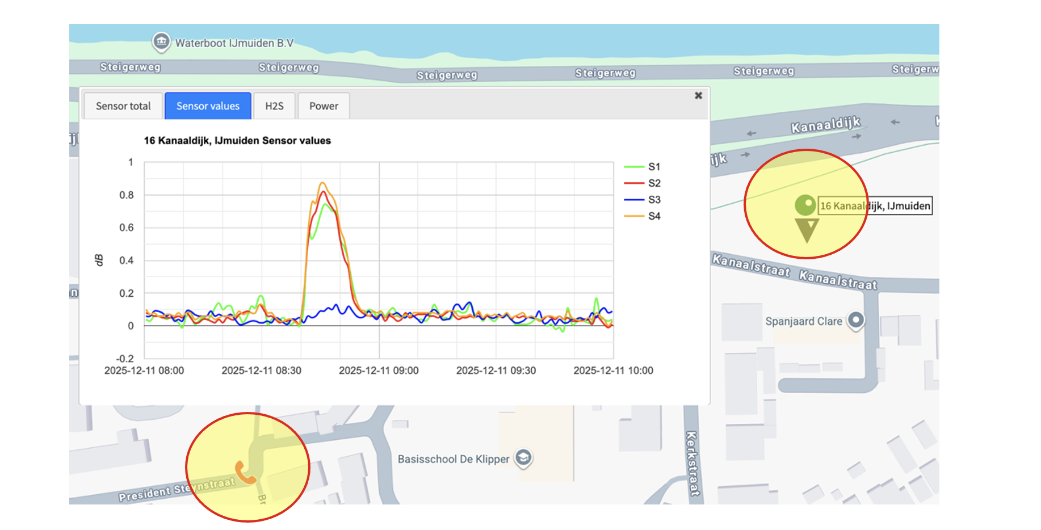
Figure 6 time and place relation between eNose recording and odour complaint

  - Conclusion

In this paper we presented a method where an eNose network was used to track the source of an emission. Two examples have been detailed in which the eNose data and recorded complaints were used to validate the plume of the dispersion of the emission.

In one of the examples the vapour that spread in the area was known. Because the eNose was trained for that vapour the eNose recordings could be translated into a odour concentration that was recorded by the eNoses.

Acknowledgements
Ralph van Nellestijn, Fleur Boesenkool, Jake van Hout, and Thonie van Lieburg

References

[1] An end-to-end data analysis framework for real-time detection and source identification of pollution events via eNose networks
Mahsa Akbari Lakeh, Simon Bootsma, Ralph van Nellestijn, Gerjen H. Tinnevelt, Jeroen J. Jansen

[2] https://www.knmi.nl/research/publications/interim-report-on-the-validation-of-harmonie

